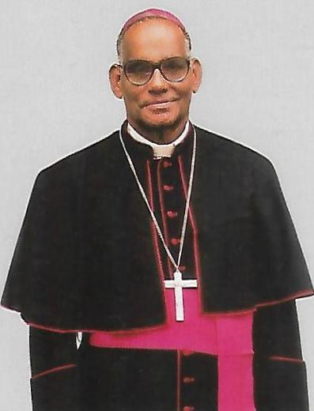

Rev. George Mamlassery, Bishop Emeritus, Diocese of Tura, Meghalaya  
(1932-2024)

The hospital started functioning in the year 1993 under the auspices of Holy Cross Congregation. Holy Cross Hospital is a Multi bedded, fabulously equipped hospital established in the year 1993 in Tura, West Garo Hills, Meghalaya. It is the fulfillment of a great dream of Most Rev. George Mamlassery, the then Bishop of Tura diocese, Meghalaya. The inadequate health care facilities in Garo Hills had invoked in his grace a missionary zeal to construct a 150 bedded hospital. The hospital has been a beacon of transformative impact, weaving hope and healing into the lives of hundreds of thousands of people from far and near. It delivers accessible and profound services in focused and caring environment with advanced facilities for minimally invasive and short stay surgeries, Obstetrics & Gynaecology and Pediatric & Neonatal care. The hospital invariably offers affordable access to various medical and surgical specialties. The diligent services fastened onto Christian values without compromising professional standards, blending latest technology and ingenious procedures remains focused on outcomes to usher in healthy and happy days.

**Specialties**

* General Medicine
* General & Laparoscopic Surgery
* Obstetrics & Gynecology
* Pediatrics & Neonatology
* Orthopedics
* Spine Surgery
* Ophthalmology
* Neurology
* Anesthesiology
* Urology & Dialysis
* Cardiology

**Facilities**

* Emergency
* Pharmacy
* Laboratory
* Radiology
* Ultrasonography
* Intensive Care Unit (ICU)
* High-Dependency Unit (HDU)
* Neonatal ICU
* Operation Theatre
* Accident & Trauma
* Food Services

**Mone : Specialities and Facilities given above should come like this with proper icons. Some icons are given in below page. Rest you take from net (Suitable ones)**

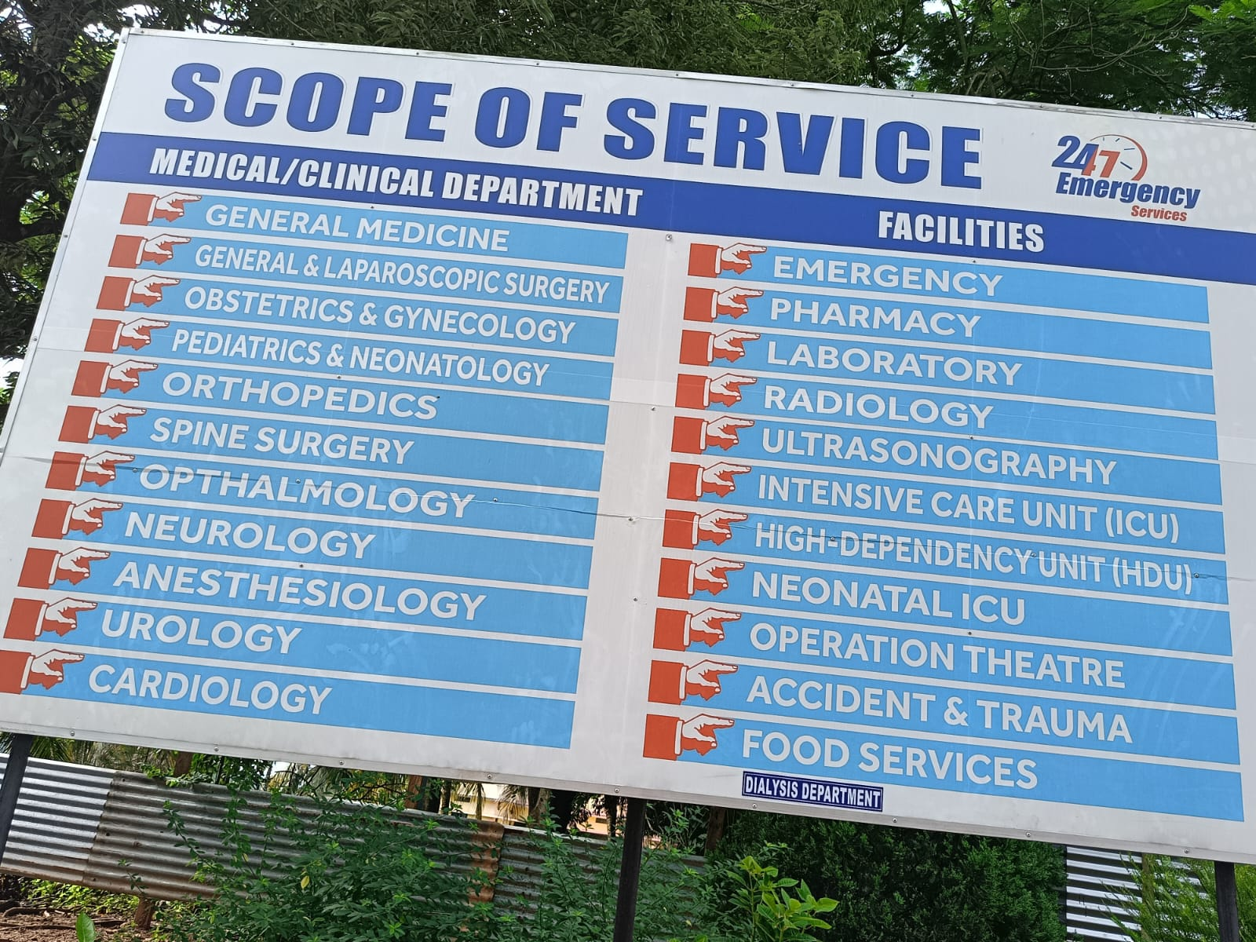

**Mone : This board mable took pic from bottom. You make another beautiful board like table with these colours or suitable colours and put suitable icons. Dialysis Department can be put in the end in the middle.**

**Mone: These below two items can be given at the end of the board in another box according to your preference**

* Cashless Insurance
* Ambulance Services

**Mone: Facility in the header of Hospital should be changed to Facilities**

**Mone : These are some icons for your help… Plz use these and take others from net**

 Ambulance

Anesthesiologist

Cardiologist

Cashless Insurance IconCashless Insurance

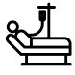ICU

Neurologist

OPD

OT Available

Pathology

Pharmacy